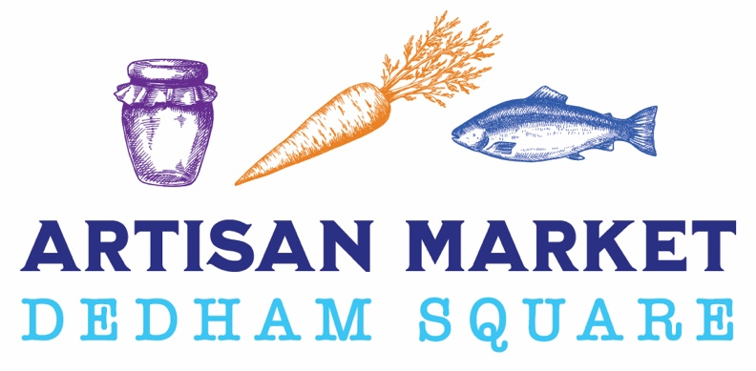
2022-2023
Winter Artisan Market Sponsorship Levels

Platinum Sponsorship (1 Available) $3,000
- Name and logo recognition on all 2022-23 sponsorship related promotional materials
- Logo prominently displayed on Artisan Market newsletter w/ link
- Logo included on 2022-2023 Artisan Market sign at entry to the Market
- Logo included in Artisan Market ads in Dedham Times, Hometown Weekly and Bulletin newspapers
- Your company’s marketing/promotional materials on display at Artisan Market Manager table
- Brand thanked and tagged individually on Artisan Market social media as a Platinum Sponsor
Gold Sponsorship (4 Available) $2,000
- Name and Logo recognition on all Artisan Market 2022-2023 sponsorship related promotional materials
- Logo prominently displayed on Artisan Market newsletter w/ link
- Logo included on 2022-2023 Artisan Market sign at entry to Market
- Logo included in Artisan Market ads in Dedham Times, Hometown Weekly and Bulletin newspapers
- Your company’s marketing/promotional materials on display at Artisan Market table
- Brand thanked and tagged on Artisan Market social media as a Gold Sponsor

Silver Sponsorship (8 Available) $1,000
- Company name on all Artisan Market related promotional materials
- Company name included in Artisan Market ads in Dedham Times, Hometown Weekly and Bulletin newspapers
- Brand thanked and tagged on Artisan Market social media in group post
Bronze Sponsorship (Unlimited) $500
- Company name on all Artisan Market related promotional materials
- Company name included in Artisan Market ads in Dedham Times, Hometown Weekly and Bulletin newspapers
- Brand thanked and tagged on Artisan Market social media in group post
Patron Sponsorship (Unlimited) $250
- Company Name included in Artisan Market Ads in Dedham Times, Hometown Weekly and Bulletin newspapers
Event Details:
Every Saturday 10am-2pm
Dec 3, 2022 - Mar 25, 2023 (except Dec 24 & 31) Dedham Town Hall-Senior Center 450 Washington Street
Dedham, MA 02026

